1. Project Introduction

1.1 Background and Problem Statement
In modern enterprise environments, critical business intelligence is often fragmented across disparate "data silos." Organizations typically manage unstructured documents in collaboration suites (e.g., SharePoint, Google Drive) while maintaining structured operational data in relational databases (e.g., PostgreSQL).
This fragmentation creates significant friction for employees, who must constantly "context switch" between multiple applications to retrieve information. Traditional search tools are limited to keyword matching and lack the cognitive ability to synthesize answers from different sources. For example, a simple query like "Compare the Q3 sales figures in the database with the Q3 marketing strategy in Google Drive" requires a human to manually retrieve, read, and correlate data from two separate systems. This manual process is time-consuming, error-prone, and creates a bottleneck in decision-making.

1.2 Project Rationale
We are developing the AI Multi-Platform Integration Agent to bridge the gap between static data repositories and dynamic user needs. The industry is shifting from passive "search engines" to active Autonomous Agents capable of reasoning and action.
We are undertaking this project to:
- Eliminate Data Silos: Create a unified, conversational interface (Single Pane of Glass) where users can access data from SharePoint, Drive, and SQL databases without needing to know where that data resides.
- Enable Complex Reasoning: Unlike standard APIs that simply fetch data, this agent uses a Reasoning Layer (LLM) to interpret the user's "intent." It can autonomously determine which "tools" to use (e.g., "Search Drive" vs. "Query Database") and aggregate the results into a coherent narrative.
- Enhance Productivity: By automating the retrieval and synthesis of information, the system significantly reduces the time spent on manual data gathering, allowing employees to focus on high-value analysis.
- Modernize Integration Architecture: The project moves away from brittle, hard-coded point-to-point integrations in favor of a Composable Agentic Workflow. This ensures the system is modular, scalable, and capable of "Self-Correction" if a data source becomes temporarily unavailable.

1.3 Strategic Value
This solution represents a paradigm shift from "Software-as-a-Service" to "Service-as-an-Agent." By implementing an architecture grounded in Retrieval-Augmented Generation (RAG) and Tool Calling, the organization gains a scalable foundation for future AI initiatives, transforming static data into actionable intelligence.

2 Project Scope
The project focuses on developing an Autonomous AI Agent built upon an Event-Driven Workflow Orchestration Engine. This system serves as a centralized intelligence layer that integrates disparate enterprise data sources—specifically SharePoint, Relational Databases (PostgreSQL), and Google Drive—into a unified conversational interface.
Unlike traditional static software, this agent employs a Retrieval-Augmented Generation (RAG) architecture. It does not merely retrieve data; it interprets user intent, autonomously selects the appropriate integration "Tools" (APIs/Connectors), and synthesizes information from multiple formats (unstructured documents vs. structured SQL rows) to generate context-aware responses.
The Scope Includes:
- Agentic Workflow Design: Implementation of logic flows for "Intent Classification" (determining what the user wants) and "Tool Routing" (deciding where to get it).
- Vector Search Integration: Indexing unstructured documents (from SharePoint/Drive) into a Vector Database to enable semantic retrieval based on meaning rather than just keywords.
- Structured Data Querying: Developing a "Text-to-SQL" capabilities agent capability to safely query relational databases.
- Human-in-the-Loop Protocols: Designing workflows that can pause execution to request human approval for high-stakes or ambiguous actions.
The Scope Excludes:
- Real-Time Bi-Directional Sync: The agent focuses on retrieval and processing of data on-demand, not keeping external databases in constant real-time sync.
- Creation of Source Systems: The project assumes SharePoint, Google Drive, and PostgreSQL instances already exist and are accessible via API.

3. High-Level Business Requirements by User Persona
To ensure the AI Multi-Platform Integration Agent delivers value across the organization, the requirements are segmented into three core personas: the Knowledge Worker (General User), the Business Analyst (Power User), and the Compliance Administrator (Governance).

3.1 Persona A: The Knowledge Worker (Operational User)
- Goal: Rapidly retrieve specific documents or information without navigating multiple complex systems (SharePoint, Drive).
- Interaction Style: Natural language questions via chat interface (e.g., "What is the travel reimbursement policy?").
Requirements:
- Semantic Document Retrieval (RAG): The system must use Vector Search to understand the meaning of a query rather than just matching keywords. It must retrieve relevant context from unstructured repositories (SharePoint, Google Drive) even if the user uses different terminology than the source document.
- Source Attribution: To build trust, every AI-generated answer must include direct links or citations to the source files (e.g., "Source: Employee_Handbook.pdf in SharePoint").
- Contextual Awareness: The agent must maintain "Conversation Memory," allowing the user to ask follow-up questions (e.g., "Does this apply to international travel?") without restating the original context.

3.2 Persona B: The Business Analyst (Analytical User)
- Goal: Synthesize data to derive insights, often combining structured metrics with unstructured narratives.
- Interaction Style: Complex, multi-part queries requiring reasoning (e.g., "Pull Q3 sales data from the database and compare it against the Q3 marketing goals in the project folder").
Requirements:
- Multi-Modal Data Synthesis: The agent must possess the Reasoning Capability to query structured SQL databases (for sales figures) and unstructured document stores (for strategy docs) simultaneously, then aggregate these distinct data types into a single analytical summary.
- Text-to-SQL Generation: The system must implement a secure SQL Tool that translates natural language requests into valid SQL queries to fetch precise metrics from the relational database (PostgreSQL).
- Structured Output Formatting: The agent must be able to format responses as tables, bulleted lists, or downloadable reports (CSV/JSON) suitable for further analysis.

3.3 Persona C: The Compliance & System Administrator (Governance)
- Goal: Ensure the agent acts securely, accurately, and within policy boundaries.
- Interaction Style: Dashboard monitoring, log review, and configuration management.
Requirements:
- Role-Based Access Control (RBAC) Inheritance: The agent must respect the permissions of the underlying platforms. It must not retrieve or display data (e.g., HR salaries from SQL or Confidential Docs from Drive) if the requesting user does not have explicit access rights to those sources.
- Full Observability & Audit Trails: The system must log the entire "Chain of Thought" for every interaction. Admins must be able to see exactly which "Tools" were called, what data was retrieved, and the raw prompt sent to the LLM to audit for hallucinations or data leakage.
- Hallucination Guardrails: The system must implement a "Confidence Score" threshold. If the AI cannot find data with high certainty, it must return a fallback message ("I cannot find this information") rather than inventing an answer

4. Architectural Requirements & Service Level Agreements (SLAs)

4.1 Service Level Agreements (SLAs)
These metrics define the expected performance and reliability boundaries of the AI Agent. Unlike standard database queries which are millisecond-fast, AI reasoning chains require seconds to execute.
A. Performance & Latency
- Simple Retrieval (Informational):
  - Definition: Queries requiring only a single Vector Search (e.g., "What is the travel policy?").
  - Target: < 3.5 seconds (95th percentile).
- Complex Reasoning (Analytical):
  - Definition: Queries requiring multi-step Tool Calling, SQL generation, or cross-platform synthesis (e.g., "Summarize the SharePoint contract and compare it to the SQL budget").
  - Target: < 15.0 seconds (allows for LLM "thinking" time and sequential API calls).
  - Constraint: User UI must display a "Thinking..." or "Processing Steps" indicator for any request exceeding 2 seconds.
B. Availability & Reliability
- System Uptime: 99.9% (allowing ~43 minutes of downtime per month for maintenance).
  - Note: High availability is achieved by deploying n8n in "Queue Mode" with multiple Worker Nodes.
- Tool Success Rate: 98%.
  - Fallback: If a specific tool (e.g., SharePoint API) fails, the system must degrade gracefully (e.g., "I can access the Database, but SharePoint is currently unresponsive") rather than crashing.
C. Throughput & Scalability
- Concurrent Users: Support for 50 concurrent active sessions initially.
- Token Throughput: The system architecture must handle bursts of up to 10,000 input tokens per minute (TPM) without throttling, managed via API quota balancing.
- Scaling Trigger: Auto-scaling of Worker Nodes triggers when CPU usage exceeds 70% for 5 minutes.
D. Data Freshness (Vector Store)
- Indexing Latency: New documents uploaded to SharePoint/Drive must be searchable within 15 minutes.
  - Mechanism: Scheduled incremental ingestion workflows (running every 10-15 mins) rather than real-time event listeners, to optimize API costs.
E. Accuracy (AI Specific)
- Hallucination Rate: < 2% on verifiable facts.
  - Control: Enforced by setting the LLM temperature to 0.0 for data retrieval tasks and using strict "Grounding" system prompts (answering only from retrieved context).

4.2 Architectural Requirements
A. Modularity (Composable Workflows)
- Requirement: The architecture must strictly follow a Composable Workflow Pattern.
- Implementation: Instead of one massive workflow, the system must be broken into:
  - Router Agent: The "Brain" that classifies intent.
  - Sub-Workflow Skills: Distinct, reusable workflows for specific tasks (e.g., sub-flow-search-sharepoint, sub-flow-query-postgres).
- Benefit: Allows individual skills to be updated, debugged, or replaced without bringing down the entire agent.
B. Security & Governance
- Credential Isolation: API Keys (OpenAI, SharePoint, DB) must be stored in the orchestration engine's secure Credential Vault and never hard-coded in workflow nodes.
- RBAC Propagation: The agent acts on behalf of the user. When querying SharePoint, it must pass the User ID to ensure it only retrieves documents that specific user is authorized to view (User-Delegated Auth).
- Data Ephemerality: Sensitive data retrieved from documents must exist only in the execution memory (RAM) during processing and must be cleared immediately after the response is generated.
C. Interoperability & Standardization
- Canonical Data Format: All tools (SQL, API, Drive) must normalize their output into a standard JSON Schema before passing data to the LLM reasoning node. This ensures the AI processes data consistently regardless of the source.
D. Observability & Tracing
- Execution Logging: Every interaction must generate a unique Execution_ID.
- Traceability: Administrators must be able to view the full "Chain of Thought" (e.g., User Input → Router Decision → Tool Output → Final Answer) in the monitoring dashboard (e.g., n8n Execution View or LangSmith) for debugging and audit purposes.

5. Architectural Methodology and Models

5.1 Architectural Methodology: Composable Agentic Workflows
The project abandons a traditional monolithic or pure microservices architecture in favor of a Composable Agentic Workflow Architecture. This methodology is centered around Orchestration rather than hard-coded application logic.
- Shift from Code to Logic: Instead of writing custom code to connect services, we define business logic as visual Directed Acyclic Graphs (DAGs) in an orchestration engine (n8n).
- Modular "Skills": Each capability of the AI is a self-contained sub-workflow (a "Skill"). For example, "Searching SharePoint" is one modular skill, and "Querying SQL" is another. The primary AI "Router" Agent autonomously decides which skill to trigger based on the user's intent.
- Event-Driven & Asynchronous: The system is fully event-driven. A user's message acts as a "trigger" event, initiating an asynchronous workflow execution that flows through necessary logic gates, tool calls, and reasoning steps before returning a response.

5.2 Architectural Models
A. The Orchestration Model (The "Brain") At the core is the Workflow Orchestration Engine. It manages state, handles errors, and executes the decision path defined by the AI.
- Main Workflow (Router): Receives the user query, uses an LLM node to classify intent (e.g., Does the user want to search a doc or query a DB?), and routes execution to the correct sub-workflow.
- Sub-Workflows (Tools): Encapsulated logic for interacting with specific external systems.
  - Tool_SharePoint_Search: Handles API auth, performs vector search, and returns chunks of text.
  - Tool_PostgreSQL_Query: Receives a natural language request, uses an LLM to generate safe SQL, executes it, and returns structured rows.
B. The Cognitive Model (RAG & Reasoning) This model defines how the system thinks and processes information.
- Reasoning Layer (LLM): An external Large Language Model (e.g., OpenAI GPT-4o, Anthropic Claude 3.5) acts as the cognitive engine. It is responsible for intent classification, SQL generation, and synthesizing the final natural language response.
- Retrieval-Augmented Generation (RAG) Layer:
  - Ingestion Pipeline: A scheduled workflow that periodically scrapes documents from SharePoint/Drive, splits them into chunks, generates vector embeddings, and upserts them into the Vector Store.
  - Semantic Retrieval: When a user asks a question, their query is converted into a vector, and a "nearest neighbor" search is performed against the Vector Store to find the most relevant context.
C. The Data Integration Model (The "Limbs") This model handles secure connections to source systems.
- Structured Data Connector: A direct, secure JDBC/ODBC connection to the PostgreSQL database, enabling the execution of read-only SQL queries generated by the AI.
- Unstructured API Connectors: OAuth2-authenticated API connections to Microsoft Graph (SharePoint) and Google Workspace API (Drive) for fetching file content and metadata.

5.3 Architecture Diagram
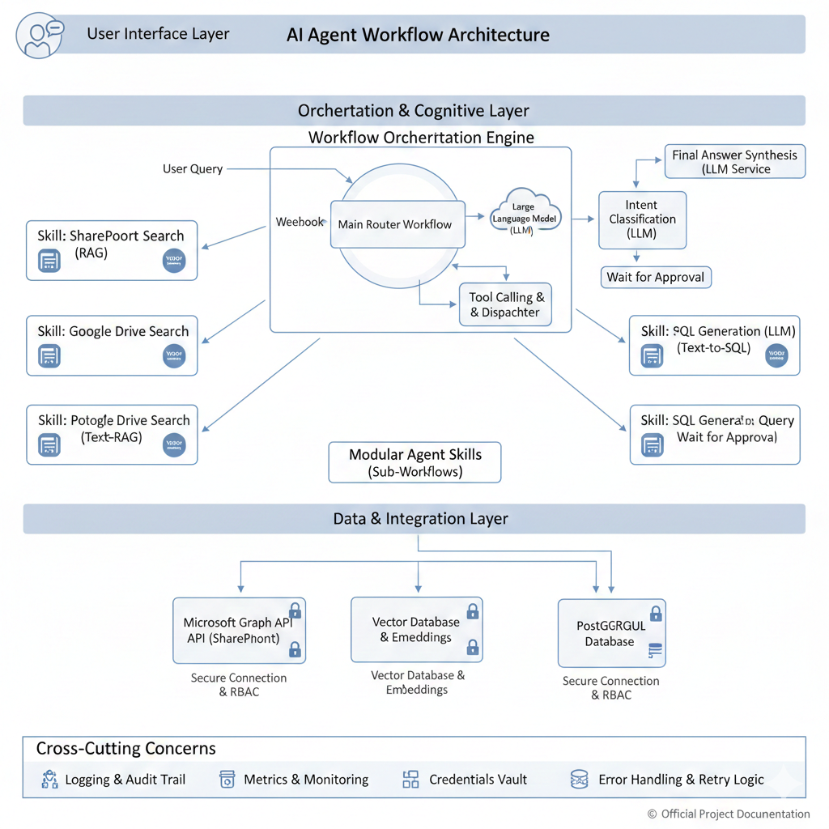
Diagram Explanation:
1. User Interface Layer:
- Represents any front-end application (e.g., custom web chat, Teams/Slack bot, internal portal) where users interact with the AI Agent. It sends user queries to the Orchestration Layer.
2. Orchestration & Cognitive Layer:
- Workflow Orchestration Engine (n8n implied): This is the core. It's a robust platform for defining, executing, and managing complex event-driven workflows.
  - Webhook: The primary entry point for user queries from the UI Layer.
  - Main Router Workflow: The "brain" that orchestrates the entire process.
    - Intent Classification (LLM): Uses a Large Language Model to understand the user's intent from their query (e.g., "Do they want to search a document, or query a database?").
    - Tool Calling & Dispatcher: Based on the classified intent, this module dynamically selects and triggers the appropriate "Skill" (sub-workflow) for execution.
    - Wait for Approval: A built-in Human-in-the-Loop mechanism to pause the workflow for human review on sensitive or ambiguous queries.
    - Final Answer Synthesis (LLM Service): After gathering information from various Skills, the LLM processes and synthesizes the retrieved data into a coherent, natural language response to the user.
  - Modular Agent Skills (Sub-Workflows): These are independent, reusable workflows, each designed to perform a specific task or interact with a particular data source. They act as "Tools" for the main router.
    - Skill: SharePoint Search (RAG): Handles fetching and processing documents from SharePoint using Retrieval-Augmented Generation.
    - Skill: Google Drive Search (RAG): Similar to SharePoint, but for Google Drive documents.
    - Skill: PostgreSQL Search (Text-RAG): Potentially for metadata or schema descriptions if performing a semantic search on the database itself, or for RAG on database documentation.
    - Skill: SQL Generation & Query (Text-to-SQL): Specifically designed to translate natural language into SQL queries, execute them against the database, and return results. Includes a "Wait for Approval" step for critical SQL operations.
3. Data & Integration Layer:
- This layer consists of the actual enterprise data sources and the secure connectors that the Agent Skills utilize.
  - Microsoft Graph API (SharePoint): Securely accesses SharePoint for document content, metadata, and user permissions.
  - Vector Database & Embeddings: Stores vectorized representations (embeddings) of unstructured documents from SharePoint and Google Drive, enabling semantic search (RAG).
  - PostgreSQL Database: The relational database storing structured business data, accessed via secure connections.
4. Cross-Cutting Concerns:
- These are foundational aspects that apply across all layers of the architecture, ensuring reliability, security, and maintainability.
  - Logging & Audit Trail: Comprehensive logging of all agent decisions, tool calls, and LLM interactions for traceability and debugging.
  - Metrics & Monitoring: Real-time dashboards to track performance (latency, throughput), errors, and system health.
  - Credentials Vault: A secure system for storing all API keys, database credentials, and other sensitive access tokens.
  - Error Handling & Retry Logic: Mechanisms built into workflows to gracefully manage API failures, network issues, and LLM timeouts, including retry strategies.

6. Infrastructure Requirements
The infrastructure for the AI Multi-Platform Integration Agent is designed for high availability, scalability, security, and specialized AI compute. It follows a hybrid cloud deployment model, leveraging cloud services for specialized components while ensuring robust orchestration.

6.1 Infrastructure Diagram: Production AI Agent Deployment
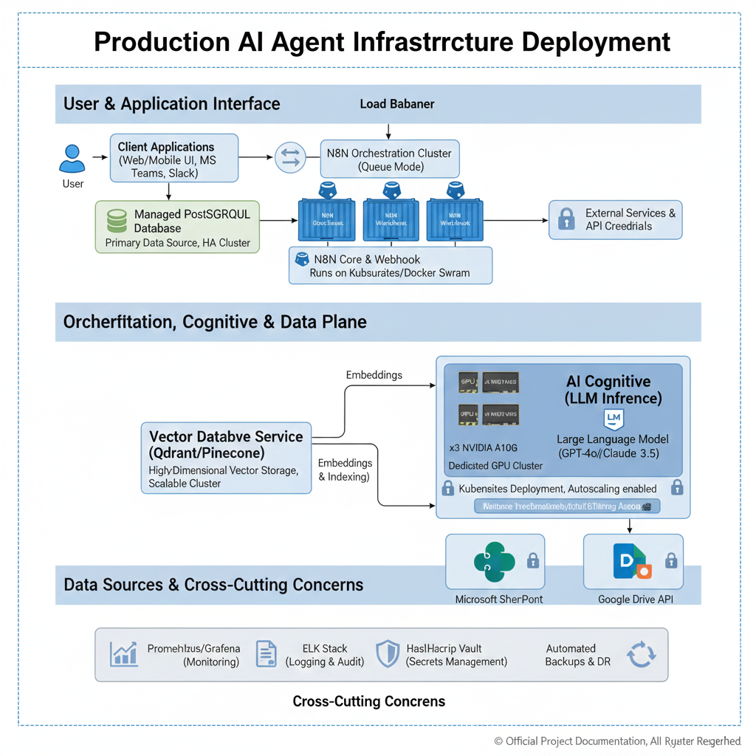
1. User & Application Interface Layer:
- Client Applications: User-facing interfaces (e.g., custom Web/Mobile UI, Microsoft Teams, Slack bots) that send requests.
- Load Balancer: Distributes incoming user requests evenly across the n8n Orchestration Cluster for high availability and performance.
2. Orchestration, Cognitive, and Data Plane:
- n8n Orchestration Cluster (Queue Mode):
  - Architecture: Deployed in Queue Mode (e.g., using Redis or RabbitMQ for queueing) on a Kubernetes cluster or Docker Swarm for resilience and horizontal scalability.
  - Components:
    - n8n Webhook Listener(s): Ingress points for API calls and user requests.
    - n8n Main Instance: Manages workflow definitions and orchestrates execution.
    - n8n Worker Nodes (xN): Execute workflow steps in parallel. Auto-scales based on workload.
- Managed PostgreSQL Database (Primary Data Source, HA Cluster):
  - The primary relational database (PostgreSQL) where core business data resides. This is a highly available (HA) cluster with automated failover and backups.
- Vector Database Service (Qdrant/Pinecone):
  - Purpose: Stores high-dimensional vector embeddings of unstructured documents (from SharePoint, Google Drive) for semantic search.
  - Architecture: A scalable, dedicated cluster or managed cloud service designed for high-throughput vector similarity search.
- AI Cognitive (LLM Inference):
  - Dedicated GPU Cluster (e.g., 3x NVIDIA A100/A10G):
    - Purpose: Provides the necessary computational power (GPUs) for running Large Language Model (LLM) inference efficiently. This is critical for low-latency responses for complex reasoning tasks.
    - Deployment: Runs on Kubernetes with autoscaling enabled (e.g., using KServe, Ray Serve, or directly managed containers) to dynamically adjust GPU resources based on demand.
  - Large Language Model (LLM): The selected LLM (e.g., GPT-4o, Claude 3.5, or a fine-tuned open-source model like Llama 3) for intent classification, SQL generation, and final answer synthesis.
3. Data Sources & Cross-Cutting Concerns:
- Microsoft SharePoint / Google Drive API: External cloud services for unstructured document storage. Accessed via their respective APIs.
- External Services & API Credentials: Represents other third-party APIs the agent might interact with (e.g., email, CRM). Access is secured.
- Prometheus/Grafana (Monitoring): For collecting and visualizing system metrics (CPU, RAM, latency, error rates) across all components.
- ELK Stack (Logging & Audit): Centralized logging (Elasticsearch, Logstash, Kibana) for all workflow executions, LLM interactions, and system events, crucial for debugging and auditing.
- HashiCorp Vault (Secrets Management): Securely stores and manages all API keys, database credentials, and other sensitive configurations, providing dynamic access.
- Automated Backups & DR (Disaster Recovery): Robust strategies for backing up all critical data (database, vector store, n8n configurations) and ensuring business continuity.

6.2 Key Infrastructure Requirements Summary:
- Compute: Dedicated GPU resources for LLM inference; high-CPU/RAM nodes for n8n orchestration.
- Scalability: Containerized (Kubernetes/Docker Swarm) deployment with horizontal autoscaling for n8n workers and GPU inference nodes.
- Resilience: High-Availability (HA) configurations for n8n, PostgreSQL, and Vector DB; automated failover.
- Security: Network segmentation, robust secrets management (Vault), RBAC enforcement at every layer.
- Observability: Centralized logging, comprehensive monitoring, and alerting.
- Data Tiering: Separation of structured data (PostgreSQL), unstructured data (SharePoint/Drive), and vectorized embeddings (Qdrant/Pinecone).

7. Infrastructure Alternatives and Trade-off Analysis
This section evaluates key infrastructure components against critical Quality Attributes to justify the proposed deployment model. The primary goal is to achieve an optimal balance between Availability, Performance, Scalability, and Cost-Efficiency for the AI Agent.

7.1 Core Orchestration Engine
Quality Attribute | Option 1: Single-Instance (Docker) | Option 2: Cluster (Kubernetes/Docker Swarm with Queue) - Selected | Trade-off Justification
Availability | Low (Single Point of Failure). Downtime for updates/crashes. | High (99.9%+). Multiple worker nodes, automated failover. | Essential for 24/7 agent operation. Prevents service disruption.
Performance | Limited by single CPU/RAM. Bottleneck for concurrent users. | High. Distributed workload, dedicated workers, queueing. | Directly addresses SLA for concurrent users and throughput.
Scalability | Manual, vertical scaling only. | Excellent. Horizontal autoscaling of workers based on load. | Critical for accommodating fluctuating user demand and batch processing for RAG ingestion.
Cost | Low initial cost. | Higher setup complexity, but potentially lower operational cost at scale due to efficient resource utilization. | Initial higher complexity is justified by superior operational resilience and cost-effectiveness for future growth.
Maintainability | Simple updates. | Complex initial setup (Kubernetes), but easier rolling updates. | Managed services or Kubernetes streamlines lifecycle management in the long term.

7.2 AI Cognitive Layer (LLM Inference)
Quality Attribute | Option 1: External LLM API (e.g., OpenAI, Anthropic) - Selected for primary inference | Option 2: Self-Hosted LLM (e.g., Llama 3 on dedicated GPU cluster) - Selected for specific cases/future | Trade-off Justification
Availability | Very High. Managed by cloud provider, often with global redundancy. | High, but depends on our infrastructure and SRE team. | Leverages provider's expertise; minimizes operational burden.
Performance | Excellent (fast inference, optimized hardware). Latency depends on network. | Potentially superior for highly specific, low-latency needs (local GPU). | External APIs provide balanced performance with no infra overhead. Self-hosted for strict latency/data sovereignty.
Scalability | Infinite. Automatically scales with demand, managed by provider. | Excellent, but requires robust Kubernetes/GPU management. | Outsourcing scalability to a provider reduces CAPEX and operational complexity.
Cost | Variable (per token/call). High volume can become expensive. | High upfront CAPEX (GPU hardware), lower variable cost. | Flexibility and immediate access outweigh per-token cost for initial phases. Self-hosting considered for massive scale/cost optimization.
Data Sovereignty | Data processed by third-party. | Full control over data residency. | External APIs chosen for performance/ease of use, with strict data handling policies. Self-hosting considered for stringent compliance.

7.3 Vector Database
Quality Attribute | Option 1: Self-Hosted (e.g., PGVector on Managed DB) | Option 2: Dedicated Vector Database Service (e.g., Qdrant, Pinecone) - Selected | Trade-off Justification
Availability | Dependent on DB cluster config. | Very High. Built for resilience, often multi-AZ. | Ensures consistent RAG capability, critical for agent reliability.
Performance (Search Latency) | Good for small datasets. Performance degrades for large-scale, high-dimensional vectors. | Excellent (<50ms for 99% of queries). Optimized for vector similarity search. | Directly impacts RAG performance and agent response time SLAs.
Scalability | Horizontal scaling challenging for vector extensions. | Excellent. Designed for elastic scaling of vector indexes. | Accommodates massive growth in document volume for RAG.
Cost | Potentially lower for small scale, but higher operational cost for tuning. | Higher cost, but includes managed services, auto-scaling, and performance guarantees. | Performance and operational simplicity justify the higher cost for critical semantic search.

7.4 Secrets Management
Quality Attribute | Option 1: Environment Variables / Config Files | Option 2: Dedicated Secrets Manager (e.g., HashiCorp Vault, AWS Secrets Manager) - Selected | Trade-off Justification
Security | Low. Prone to leakage, no rotation. | High. Centralized, encrypted storage, dynamic secrets, auditing. | Non-negotiable for data protection and compliance in an enterprise AI agent.
Compliance | Difficult to meet standards. | Excellent. Auditable access logs, strong encryption. | Fulfills stringent security and audit requirements.
Maintainability | Manual updates, inconsistent across environments. | Automated rotation, centralized management. | Reduces operational overhead and human error.

8. Component Orchestration and Communication Flow
The orchestration of components in the AI Multi-Platform Integration Agent follows an event-driven, hub-and-spoke model. The Orchestrator (n8n Workflow Engine) acts as the central hub, managing the state of each request and coordinating communications between the user, the cognitive reasoning layer, and the various specialized "skills."
The following Sequence Diagram illustrates the step-by-step communication flow for a typical user query that requires searching a document repository.
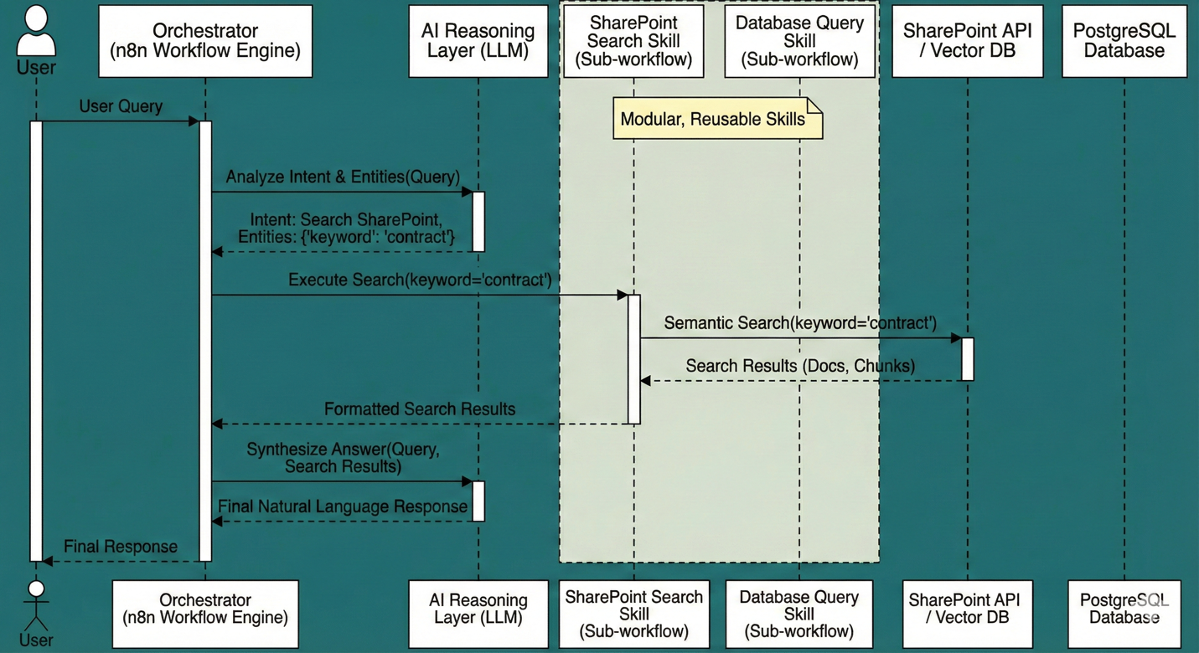
Diagram Explanation:
- User Query: The process begins when a User submits a natural language query (e.g., "Find the latest contract") to the system via a chat interface.
- Intent Classification: The Orchestrator receives the query and first sends it to the AI Reasoning Layer (LLM). The LLM's job is not to answer the question yet, but to classify the user's intent and extract relevant entities (e.g., Intent: Search SharePoint, Entity: keyword='contract').
- Tool Routing (Skill Execution): Based on the determined intent, the Orchestrator dynamically routes the request to the appropriate Modular Skill. In this case, it calls the SharePoint Search Skill (Sub-workflow), passing the extracted keyword.
- Data Retrieval: The SharePoint Search Skill executes its logic, which involves performing a Semantic Search against the SharePoint API / Vector DB. The most relevant document chunks are retrieved.
- Data Return: The SharePoint Search Skill formats the retrieved results and returns them to the main Orchestrator.
- Response Synthesis: The Orchestrator now possesses both the original user query and the retrieved context. It sends this combined information back to the AI Reasoning Layer (LLM) with a prompt to synthesize a final, natural language answer based only on the provided context.
- Final Response: The AI Reasoning Layer generates the final response, which the Orchestrator then delivers back to the User.
This orchestration pattern ensures that the AI's reasoning is separated from tool execution, making the system highly modular, easier to debug, and capable of handling complex, multi-step tasks.

9. CI/CD Pipeline and Deployment Strategy
A robust Continuous Integration/Continuous Deployment (CI/CD) pipeline is paramount for the AI Multi-Platform Integration Agent to ensure rapid, reliable, and scalable deployments. Given the workflow-centric nature of the application (n8n on Kubernetes), the CI/CD strategy focuses on automating workflow versioning, containerization, and orchestrated deployments.
9.1 CI/CD Workflow Diagram
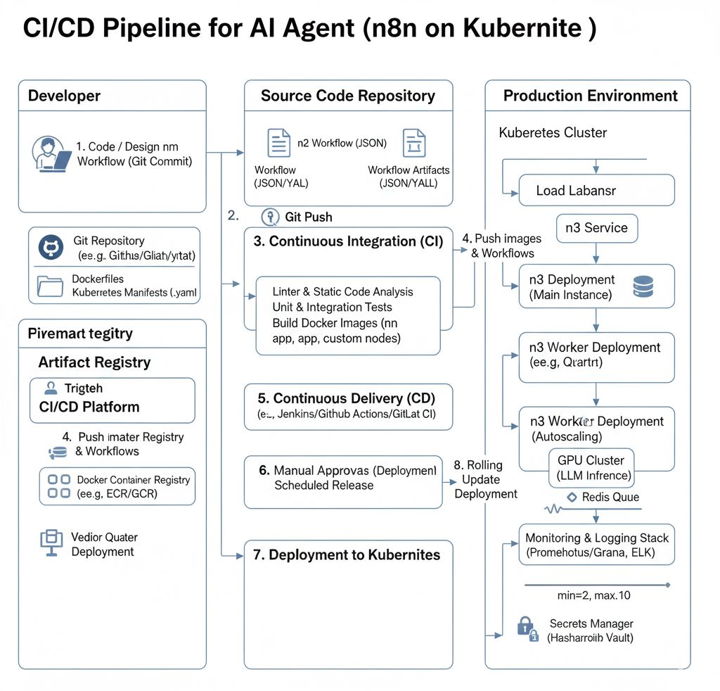
9.2 Detailed CI/CD Pipeline Stages

The CI/CD pipeline is broken down into distinct stages, each with specific tools and objectives:
1. Developer Workflow & Source Code Management
- Process:
  - Code & Workflow Design: Developers design or modify n8n workflows (which are JSON definitions), write custom n8n nodes (if any), and define Kubernetes manifests (.yaml files for deployments, services, autoscaling rules).
  - Version Control: All code and workflow definitions are managed in a Git repository (e.g., GitHub, GitLab, Bitbucket). This includes Dockerfiles for n8n and custom nodes, n8n workflow JSONs, and Kubernetes configuration files.
- Key Tools:
  - Git: For version control.
  - Integrated Development Environment (IDE): For writing code and designing workflows.
2. Git Push (Trigger CI)
- Process: A developer commits changes and pushes them to the central Git repository. This git push event automatically triggers the Continuous Integration (CI) pipeline.
- Key Tools:
  - Git Hooks / Webhooks: Configured in the Git repository to send notifications to the CI/CD platform (e.g., Jenkins, GitHub Actions, GitLab CI/CD) upon new commits or pull requests.
3. Continuous Integration (CI)
- Objective: To ensure code quality, functional correctness, and build reproducible artifacts.
- Process:
  - Linter & Static Code Analysis: Code is analyzed for style, potential bugs, and security vulnerabilities (e.g., SonarQube for custom nodes, jsonlint for n8n workflows).
  - Unit & Integration Tests: Automated tests are run for custom n8n nodes and to validate the logic of key n8n workflows (e.g., using n8n's internal testing capabilities or external frameworks to simulate workflow execution).
  - Build Docker Images:
    - n8n App Image: A Docker image for the n8n main instance and worker nodes (often based on the official n8n image, with project-specific configurations or custom nodes baked in).
    - Custom Nodes: Separate Docker images for any custom-developed n8n nodes.
    - LLM Inference Images: (If self-hosting an LLM) Docker images containing the LLM model and inference server.
  - Artifacts: The successfully built Docker images are tagged with version numbers (e.g., Git commit SHA, build number) and pushed to a Docker Container Registry.
- Key Tools:
  - Jenkins / GitHub Actions / GitLab CI/CD: Orchestrates the CI steps.
  - Docker: For building container images.
  - Docker Container Registry: (e.g., Docker Hub, Google Container Registry (GCR), Amazon ECR, Azure Container Registry (ACR)) For storing and versioning Docker images.
4. Push Images & Workflows to Registry / Deployment Repository
- Process: After a successful CI build, the Docker images are stored in the Artifact Registry. n8n workflow definitions (JSON files) and Kubernetes manifests (.yaml) are also typically stored in a versioned artifact repository or directly in the Git repository if managed as "GitOps" manifests.
- Key Tools:
  - Docker Container Registry: (As above)
  - Artifact Repository: (e.g., Nexus, Artifactory) or Git for manifest management.
5. Continuous Delivery (CD) - Pre-Deployment
- Objective: To prepare for deployment, often involving approval gates or scheduled releases.
- Process: The CD pipeline takes the validated artifacts and prepares them for deployment. This stage might include:
  - Configuration Management: Applying environment-specific configurations (e.g., API keys, database connection strings) using tools like Helm or Kustomize.
  - Security Scans: Further scans on Docker images for known vulnerabilities.
  - Approval Gates: For critical environments (e.g., Production), a manual approval step might be required before proceeding to actual deployment.
  - Scheduled Releases: Deployments can be scheduled for off-peak hours or specific release windows.
- Key Tools:
  - Jenkins / GitHub Actions / GitLab CI/CD: Orchestrates the CD steps.
  - Helm / Kustomize: For templating and managing Kubernetes configurations.
6. Deployment to Kubernetes
- Objective: To deploy the application components to the target Kubernetes cluster.
- Process:
  - Kubernetes Manifests Application: The CI/CD pipeline applies the versioned Kubernetes manifests (.yaml files) to the target cluster. This includes:
    - n8n Service: Defines how the n8n application is exposed (e.g., via LoadBalancer).
    - n8n Main Instance Deployment: The deployment for the core n8n application.
    - n8n Worker Deployment: The deployment for n8n worker nodes, often configured for horizontal autoscaling.
    - GPU Cluster Deployment (LLM Inference): Deployment for the dedicated GPU-enabled inference servers, also configured for autoscaling.
    - Redis Queue Deployment: (If using Redis for n8n queue mode)
  - Secrets Integration: Kubernetes deployments securely fetch sensitive configurations (API keys, database credentials) from a Secrets Manager (e.g., HashiCorp Vault) at deployment time, rather than baking them into images.
  - Rolling Updates: Deployments are performed as rolling updates to ensure zero-downtime during application upgrades.
- Key Tools:
  - Kubectl: Kubernetes command-line tool.
  - Helm / Argo CD / Flux CD: For managing complex deployments and enabling GitOps practices.
  - Secrets Manager: (e.g., HashiCorp Vault, Kubernetes Secrets with external integration)

9.3 Autoscaling Details
The CI/CD pipeline also plays a critical role in setting up and managing autoscaling to meet user demand, as discussed in the SLA section.
- Horizontal Pod Autoscaler (HPA):
  - n8n Worker Deployment: HPAs are configured to automatically scale the number of n8n worker pods up or down based on CPU utilization or custom metrics (e.g., queue length of pending n8n jobs).
    - Example: min_replicas=2, max_replicas=10, target_cpu_utilization=70%.
  - GPU Cluster (LLM Inference): HPAs or dedicated GPU autoscalers (like Kubernetes' Karpenter or cloud-provider specific autoscalers) scale the number of GPU-enabled inference pods based on GPU utilization, request queue depth, or custom metrics.
    - Example: min_gpu_pods=1, max_gpu_pods=3, target_gpu_utilization=60%.
- Cluster Autoscaler:
  - Works in conjunction with HPA. If HPAs try to scale pods but there aren't enough nodes in the Kubernetes cluster, the Cluster Autoscaler adds new nodes (VMs with appropriate CPU/GPU resources) to the cluster.

8.4 Monitoring & Logging Integration
- Objective: To provide real-time visibility into the health and performance of the deployed application.
- Process: The CI/CD pipeline ensures that all deployed components are configured to:
  - Emit Metrics: Application components (n8n, LLM servers) expose metrics (e.g., HTTP request count, latency, error rates, queue sizes).
  - Generate Logs: All activity, including workflow executions, LLM calls, and system events, is logged.
- Key Tools:
  - Prometheus / Grafana: For collecting, storing, and visualizing metrics, and defining alerts.
  - ELK Stack (Elasticsearch, Logstash, Kibana): For centralized log aggregation, searching, and analysis.

